Let it be known to all that

______________________________________________________________________________________________________________________
Have completed Forest City Dog Training Club's established
Course of study and are hereby awarded this certificate for
Nitty Gritty Obedience

On this Day of in the year of 20______
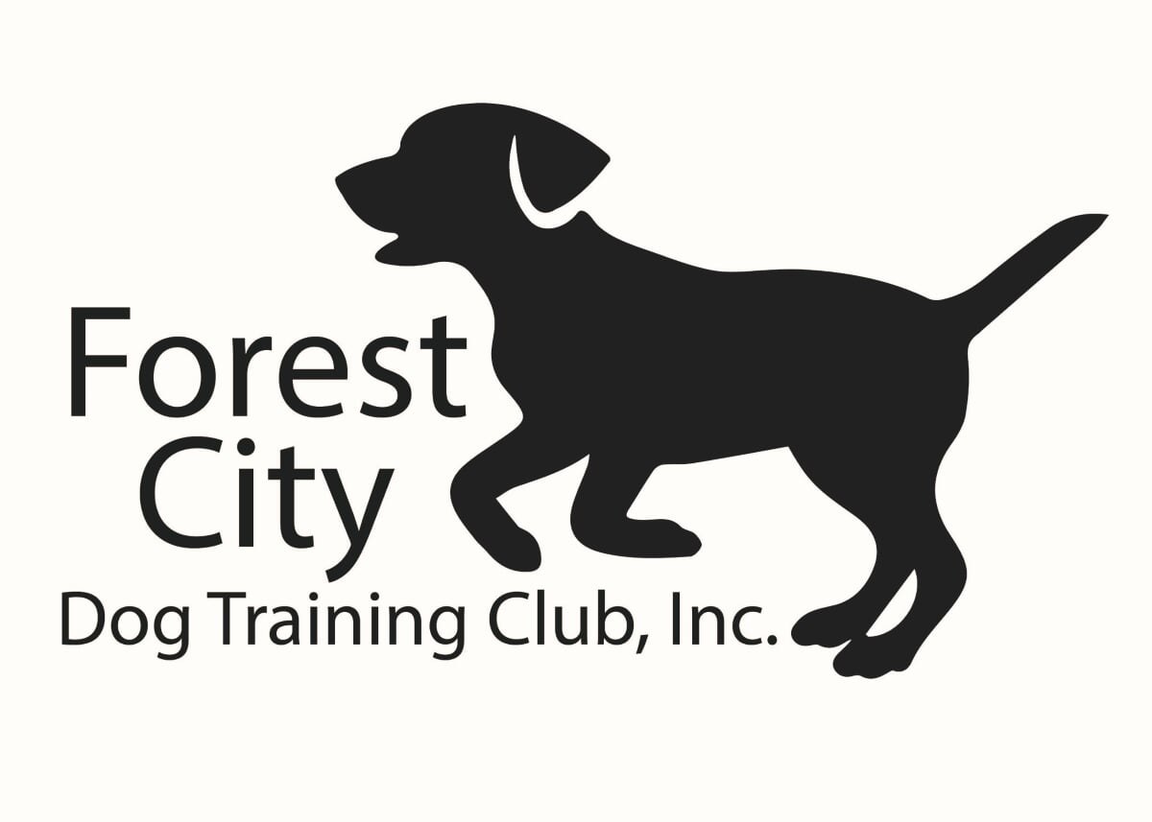 ________________________________________ ____________________________________ Director of Training Instructor

