Let it be known to all that

______________________________________________________________________________________________________________________
Have completed Forest City Dog Training Club's established
Course of study and are hereby awarded this certificate for
Advanced CGCA Obedience

On this ___________________ Day of ___________________, in the year of 20______
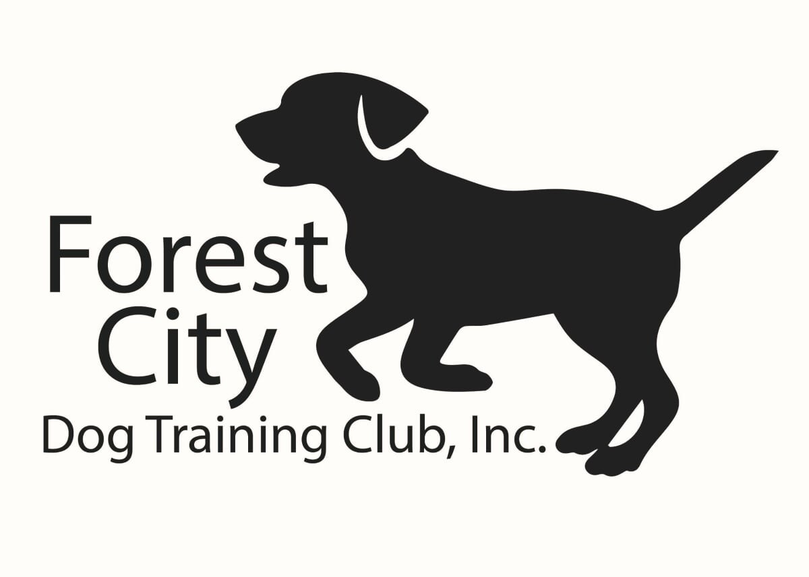 ________________________________________ ____________________________________ Director of Training Instructor

